REFLECTIONS BOOLEAN ASSIGNMENT
Student Name
Institution
Course Name/Number
Due Date
Instructor Name

The summary of this digital assignment revolves around obtaining the truth tables and the K-Map equivalent that simplifies the Boolean expressions. Such an a approach explains the methodology associated with the laboratory experiment while laying an intuitive understanding of other concepts such as the Ladder diagram expressions of the total rungs based on the Time on Delay, Timer, Time Base, Preset, Accumulation value. The concept with the switches and Garage lights is a Boolean expression in the practical sense and its explanation lies in developing the truth tables and K-Map equivalents

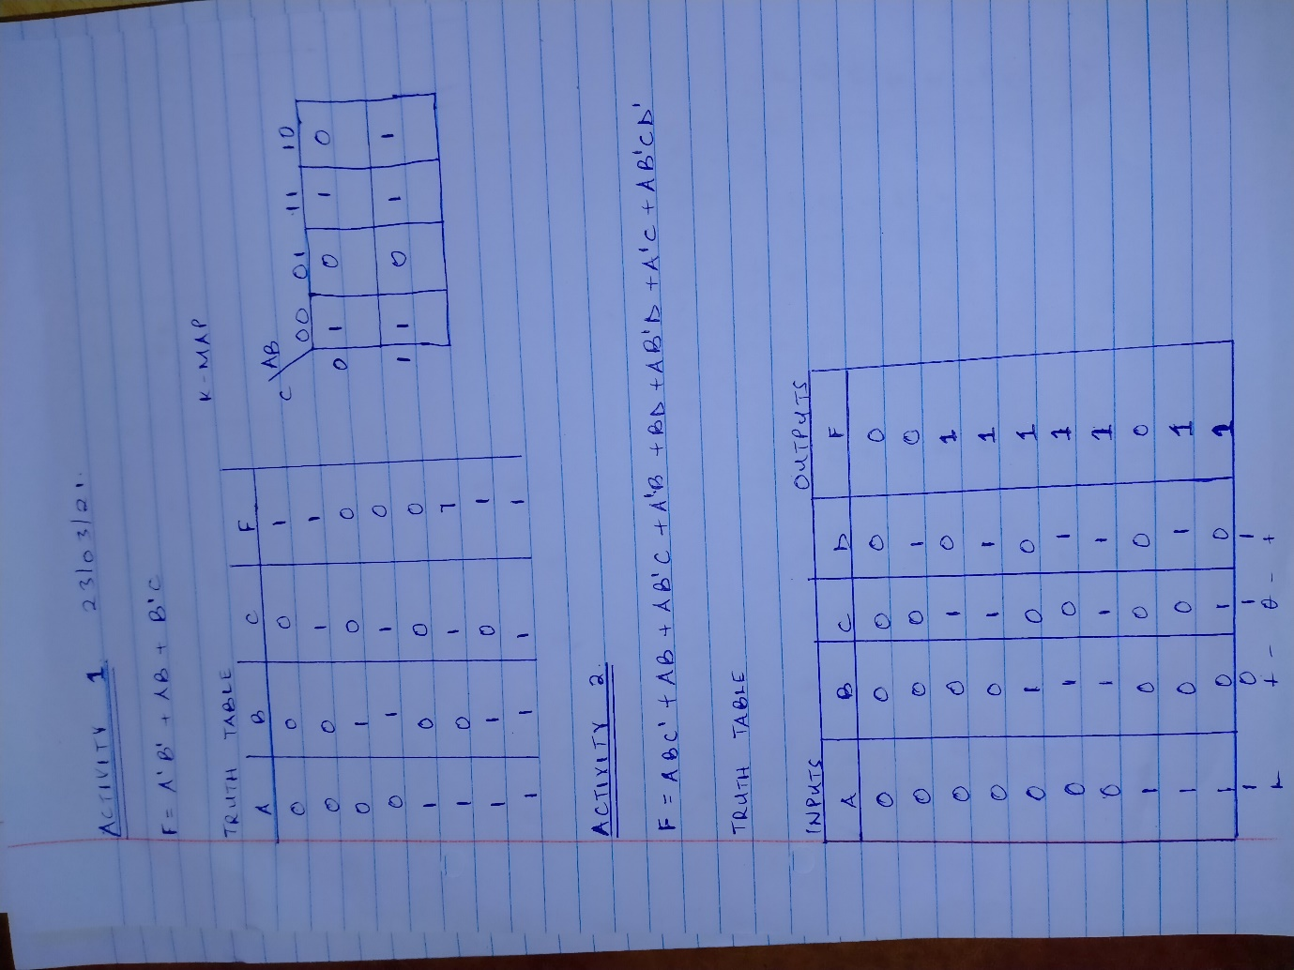
Figure showing the input and output relationship in the circuit in the Lab Activity.
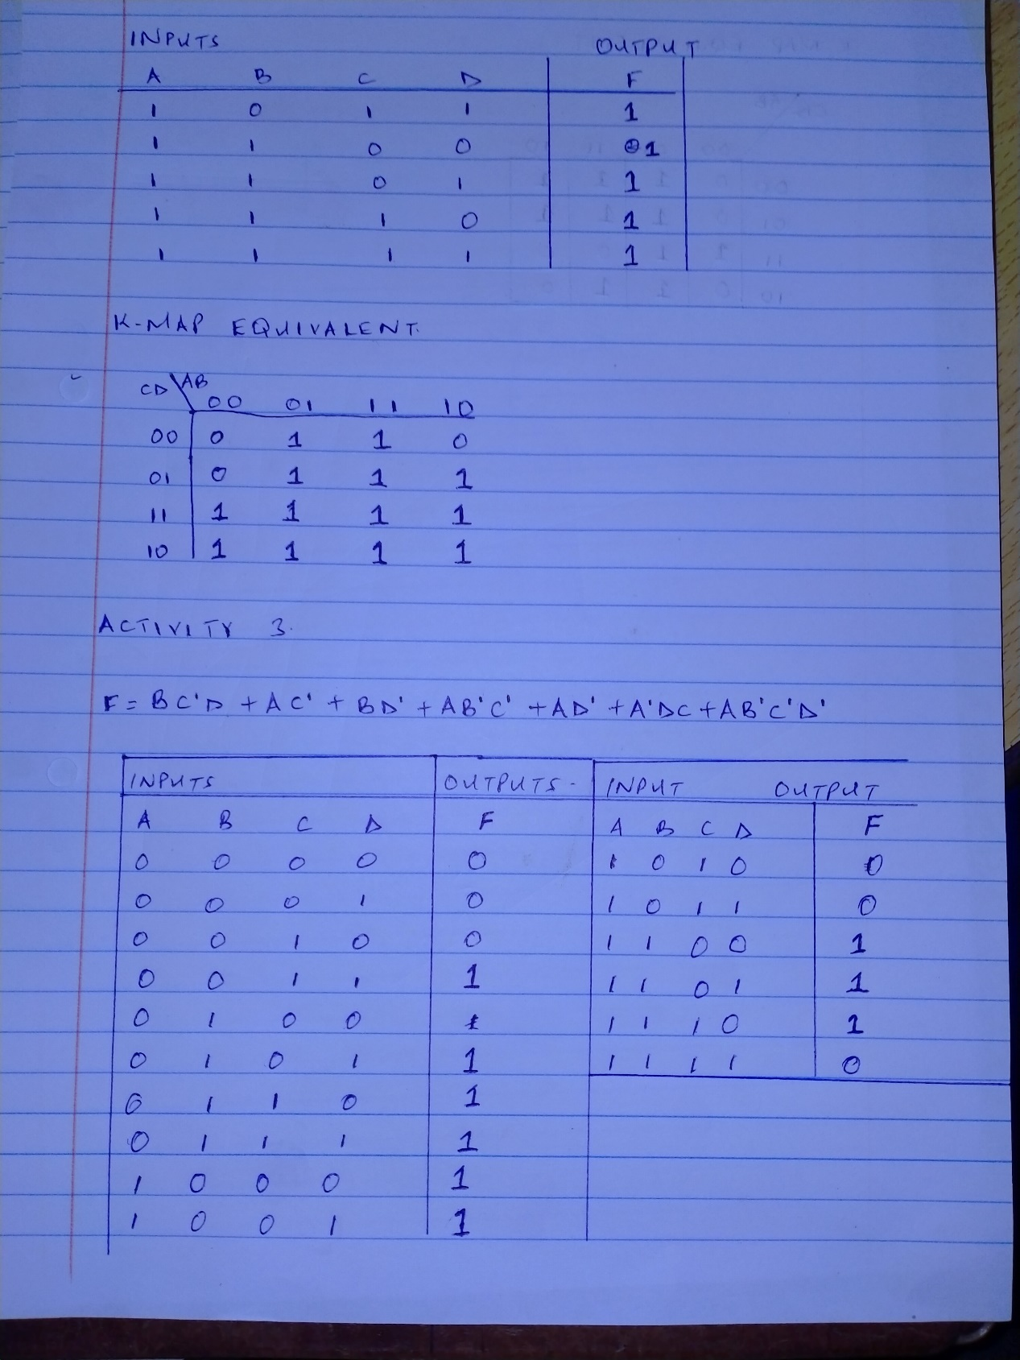
Figure showing the input output relationship plus the K-Map Equivalent in the activity.
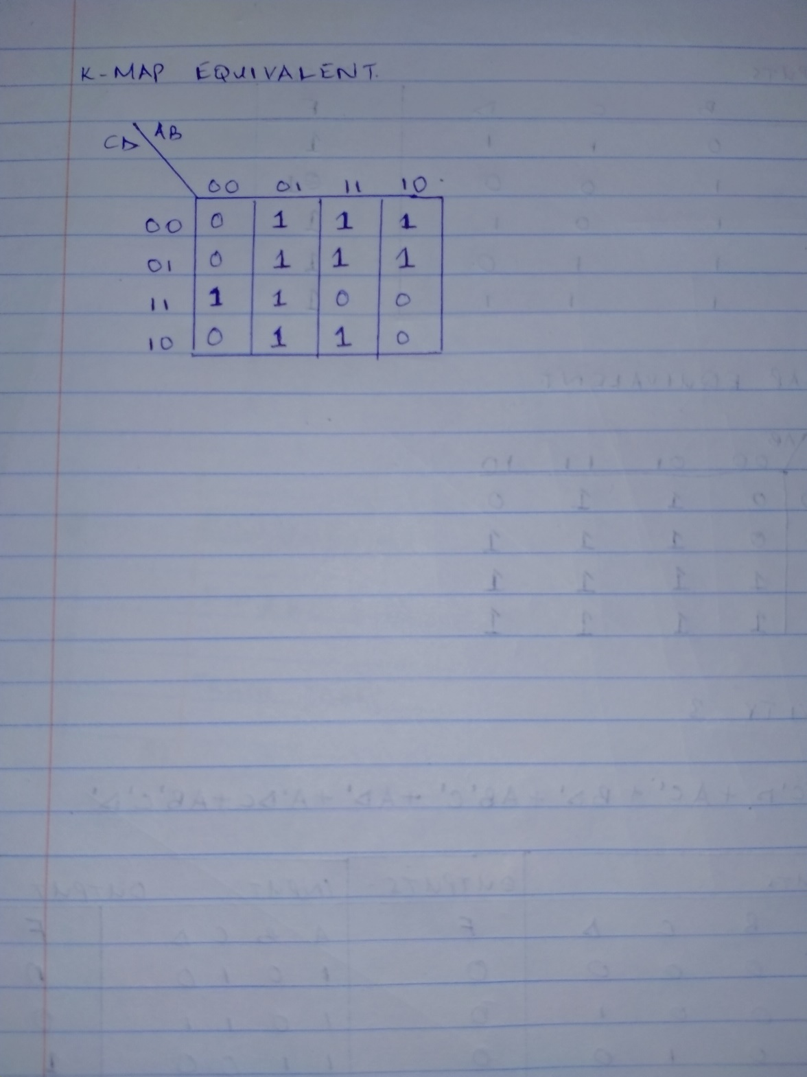
Figure showing the K-Map equivalent in the Lab Exercise.
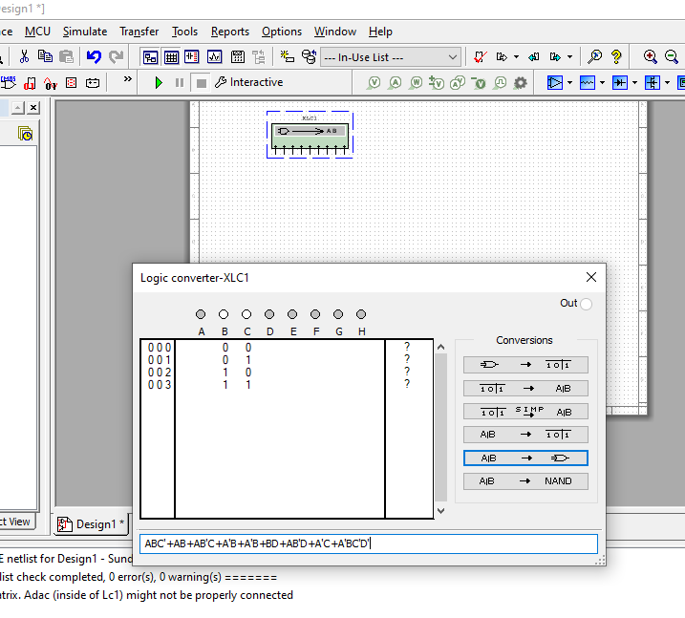
Figure showing the Boolean conversion in the circuit for Activity 1 25/03/2021
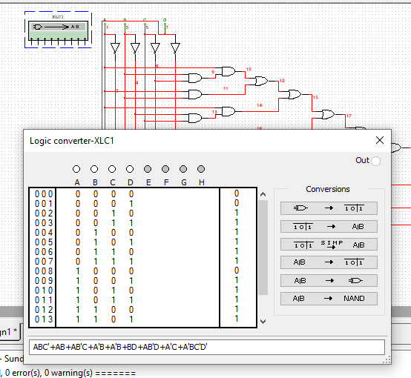
Figure showing the Truth Table in the circuit for Activity 1 25/03/2021
The simplification using K-Map of the Boolean Expression results to F=AD+B+C, therefore for the getting the output either both AD are ON (High Logic Level), B or C are ON. The same is true from the Truth Table above

Figure showing the Logic converter simulation from Multisim software.
In summary, the laboratory exercise presents the concepts of Digital Logic not just in expressing the Boolean expressions but also in developing practical circuits such as the Ladder diagram illustrating the Bulbs with the Switches & Garage lights. The understanding behind this laboratory exercise forms the basis of developing feasible digital systems e.g., Microprocessors, Microcontroller and other semiconductors that rely on the Boolean Logic.

REFERENCES
Jain, R. P. (2003). Modern digital electronics. Tata McGraw-Hill Education.
Maini, A. K. (2007). Digital electronics: principles, devices and applications. John Wiley & Sons.

